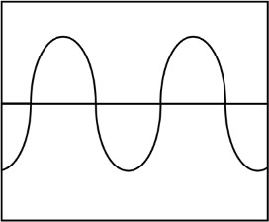
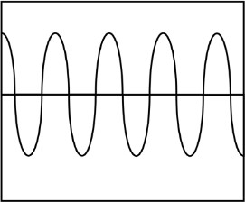
Here are two diagrams of sound waves. Label one diagram high pitch and one diagram low pitch.
Explain why sound travels faster through solids and liquids than gases.
Which of these sentences is true? Tick the right one.

Sound travels faster in water
than in air.

Sound travels faster in air than in water.
Sound travels at the same speed in water as it does in air.
Give two reasons why sounds get quieter over distance.
Fill in the gaps.

Sound travels much than light. This means you will something before you it.

Which of these statements is true? Sound doesn’t travel in space. Sound travels more slowly in space.
Sound travels more quickly in space.

Explain your answer.
are changed to and sent to your .
Sound is made when air molecules
. The vibrations reach your .The vibrations
Fill in the missing words:

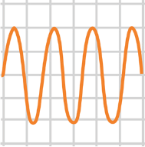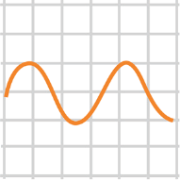
is the measure of how
loud or quiet a sound is.
Here are two diagrams of sound waves. Label one diagram quiet and one diagram loud.
Write true or false next to each sentence.

The bigger the vibration, the louder the sound. The faster the vibration, the lower the pitch.
High and low sounds are the same as loud and quiet sounds.

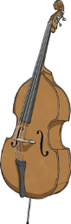
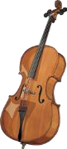


Match the instrument with
(Clue: compare their sizes.)
its
pitch.
double bass
cello
low
violin
medium
Which of these sentences is true? Tick the right one.

Sound travels faster in water
than in air.

Sound travels faster in air than in water.
Sound travels at the same speed in water as it does in air.
Fill in the gaps.

Sound travels much slower than light. This means you will see something before you hear it.
Give two reasons why sounds get quieter over distance.
Example answer: The further the vibrations travel, the more they spread out. As they spread out through more and more particles, the vibrations become smaller and smaller. This causes the sound to get quieter and quieter. Sounds also get quieter over distance because some of the vibrations
are absorbed by obstacles they meet.
Explain why sound travels faster through solids and liquids than gas.
Answers should refer to the fact that molecules in solids and liquids are closer to each other, so the vibrations travel more quickly and easily.
Here are two diagrams of sound waves. Label one diagram high pitch and one diagram low pitch.

low pitch

high pitch

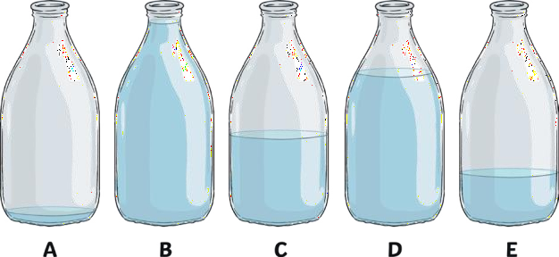

Put these in order of pitch from highest to lowest when blown across the top.

B, D, C, E, A
Which of these statements is true? Sound doesn’t travel in space. Sound travels more slowly in space.
Sound travels more quickly in space.

Explain your answer.
Answers should refer to there being no air particles in space so there are no molecules to vibrate.
Write true or false next to each sentence.

The bigger the vibration, the louder the sound. True
The faster the vibration, the lower the pitch. False
High and low sounds are the same as loud and quiet sounds. False
How can you make the pitch of a guitar note higher?
Answers could refer to making the string more taut and making the string shorter by pressing down on the fret.
Fill in the missing words:

Sound is made when air molecules vibrate. The vibrations reach your ear. The vibrations are changed to electrical signals and sent to your brain.

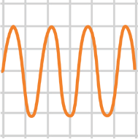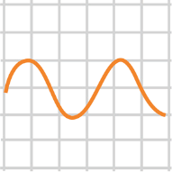
Amplitude is the measure of how loud or
quiet a sound is.
Here are two diagrams of sound waves.
Label one diagram
diagram loud.
quiet
and one
loud
quiet

